CRUD - MVC 5 and Web API 2

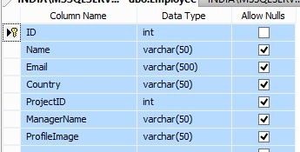

**1. ADDNewEmployee**

1. **CREATE** **PROCEDURE** [dbo].[ADDNewEmployee]
2. (
3. @Emp_Name     **VARCHAR**(100) = null,
4. @Email        **VARCHAR**(500) = null,
5. @Country      **VARCHAR**(100) = null ,
6. @ProjectID    **INT**,
7. @ManagerName  **VARCHAR**(100) = null,
8. @ProfileImage **VARCHAR**(100) = null
9. )
10. **AS**
12. **BEGIN**
13. **INSERT** **INTO** Employee (**Name**, Email,Country,ProjectID,ManagerName,ProfileImage)
14. **VALUES** (@Emp_Name, @Email, @Country,@ProjectID,@ManagerName, @ProfileImage)
15. **END**

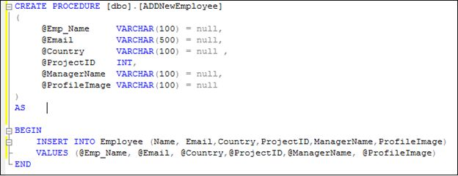  
Image 3.  
  
**2. UpdateEmployee**

1. **CREATE** **PROCEDURE** [dbo].[UpdateEmployee]
2. (
3. @Emp_ID **INT**,
4. @Emp_Name     **VARCHAR**(100) = null,
5. @Email        **VARCHAR**(500) = null,
6. @Country      **VARCHAR**(100) = null ,
7. @ManagerName  **VARCHAR**(100) = null
8. )
9. **AS**
11. **BEGIN**
12. **UPDATE** Employee
13. **SET** **Name**=@Emp_Name,
14. Email=@Email,
15. Country=@Country,
16. ManagerName=@ManagerName
17. **WHERE** ID=@Emp_ID
18. **END**

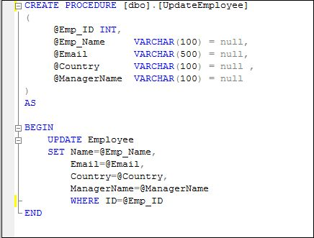  
Image 4.  
  
**3. DeleteEmployee**.

1. **ALTER** **PROCEDURE** [dbo].[DeleteEmployee]
2. (
3. @Emp_ID **INT**
4. )
5. **AS**
6. **BEGIN**
7. **DELETE** **FROM** Employee **WHERE** ID=@Emp_ID
8. **END**

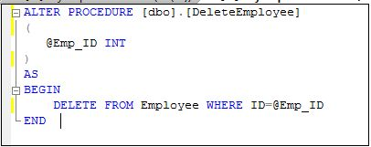  
Image 5.  
  
**4. ReadAllEmployee**

1. -- EXEC [ReadAllEmployee] null, null, null
2. **ALTER** **PROCEDURE** [dbo].[ReadAllEmployee]
3. (
4. @Emp_Name  **VARCHAR**(100) = null,
5. @Country   **VARCHAR**(100) = null,
6. @ManagerName **VARCHAR**(100)   = null
7. )
8. **AS**
9. **BEGIN**
10. IF  (@Emp_Name **IS** NULL)
11. **BEGIN**
12. **SET** @Emp_Name=''
13. **END**
14. IF  (@Country **IS** NULL)
15. **BEGIN**
16. **SET** @Country=''
17. **END**
18. IF  (@ManagerName **IS** NULL)
19. **BEGIN**
20. **SET** @ManagerName=''
21. **END**
23. **SELECT** ID, **Name**, Email, Country, ManagerName
24. **FROM**  Employee
25. **WHERE** **Name** like  @Emp_Name +'%'
26. AND Country like @Country +'%'
27. AND ManagerName like @ManagerName +'%'
28. **ORDER** **BY** **Name**
29. **END**

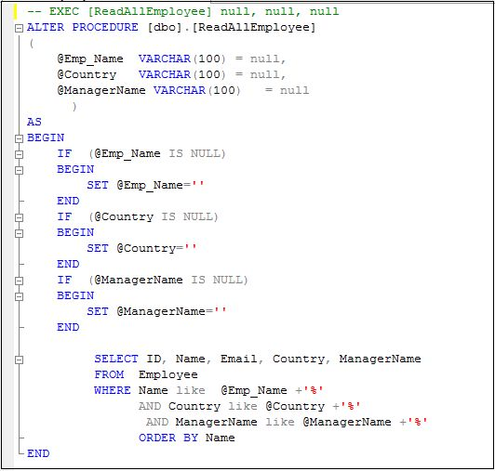  
Image 6.  
  
Now open Visual Studio 2015 and create new ASP.NET web application.  
  
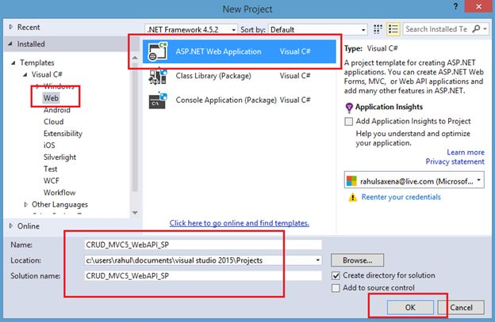  
Image 7.  
  
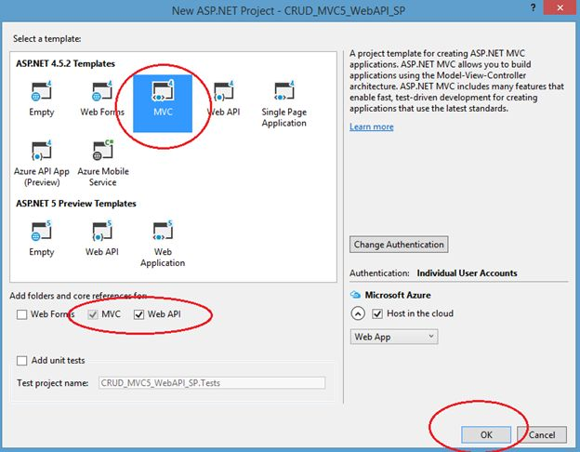  
Image 8.  
  
Now right-click on the project in the Solution Explorer as in the following:  
  
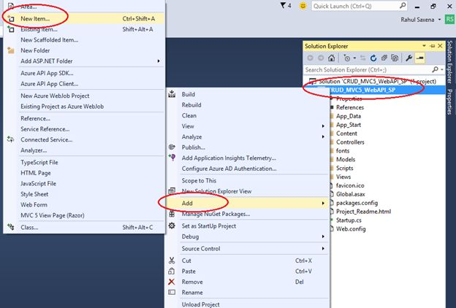  
Image 9.  
  
Select ADO.NET Entity Data Model.  
  
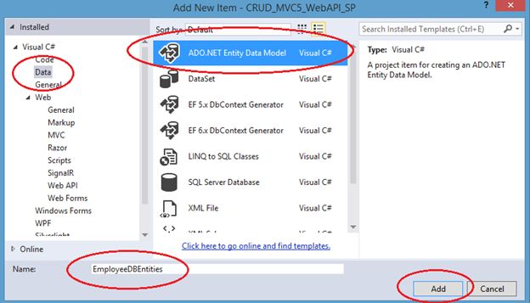  
Image 10.  
  
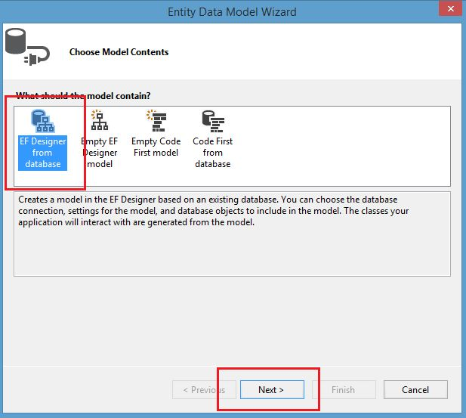  
Image 11.  
  
Select your Data Source and database.  
  
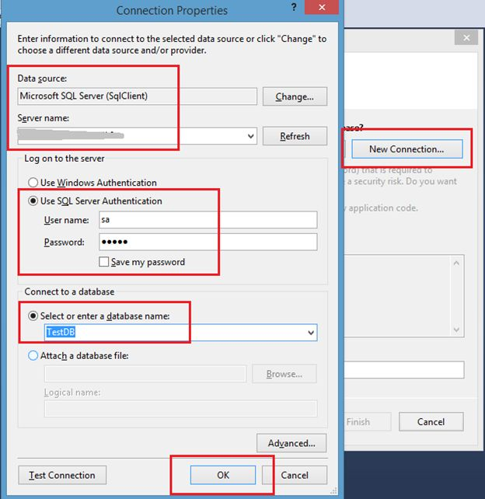  
Image 12.  
  
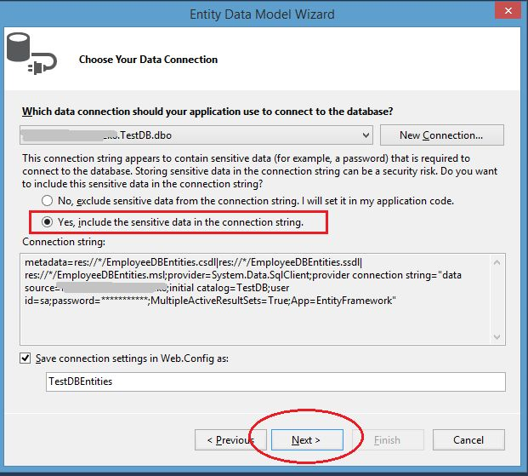  
Image 13.  
  
Select your data table and Stored Procedure.  
  
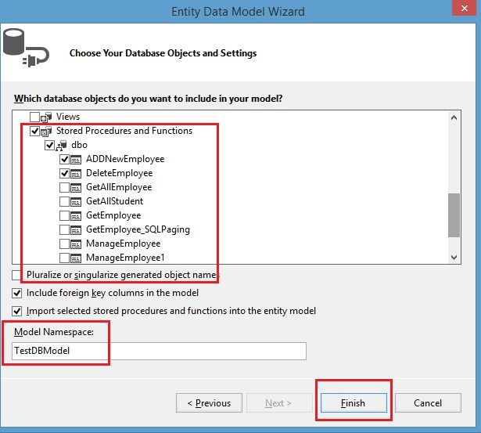  
Image 14.  
  
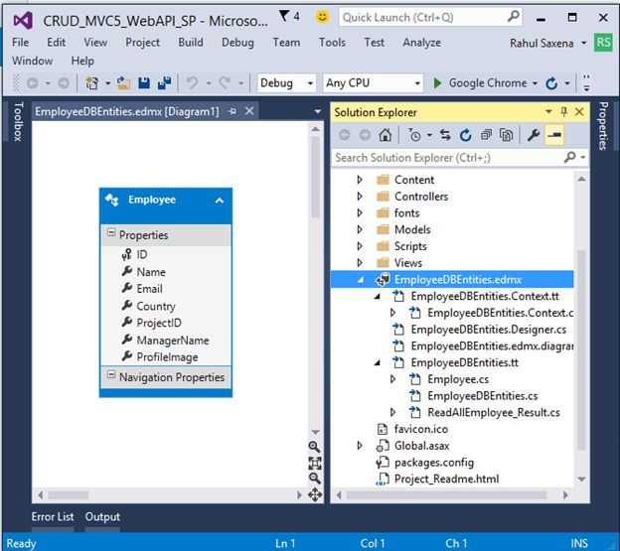  
Image 15.  
  
Now to add a Web API controller. So right-click on Controllers and Add New Controller.  
  
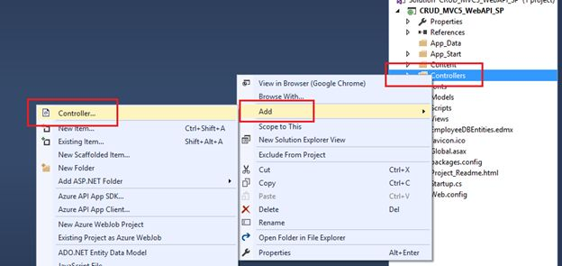  
Image 16.  
  
Select *Web API 2 Controller – Empty*.  
  
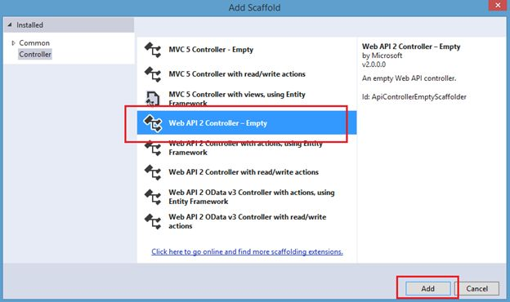  
Image 17.  
  
Provide it a name.  
  
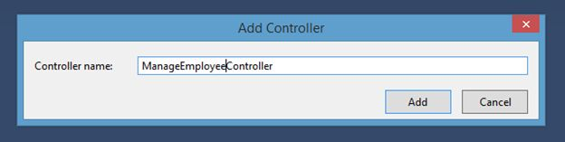  
Image 18.  
  
Here's the code:

1. **using** System;
2. **using** System.Collections.Generic;
3. **using** System.Linq;
4. **using** System.Net;
5. **using** System.Net.Http;
6. **using** System.Web.Http;
7. **using** CRUD_MVC5_WebAPI_SP.Models;
9. **namespace** CRUD_MVC5_WebAPI_SP.Controllers
10. {
11. **public** **class** ManageEmployeeController : ApiController
12. {
13. TestDBEntities obj = **new** TestDBEntities();
15. [HttpGet]
16. **public** IEnumerable<ReadAllEmployee_Result> ListAllEmployee(**string** emp_Name, **string** country, **string** managerName)
17. {
18. **return** obj.ReadAllEmployee(emp_Name, country, managerName).AsEnumerable();
19. }
21. [HttpGet]
22. **public** **void** addNewEmployee(**string** emp_Name, **string** email, **string** country, **string** managerName)
23. {
24. obj.ADDNewEmployee(emp_Name, email, country, 1, managerName, "Profile.jpg");
25. }
27. [HttpGet]
28. **public** **void** updateEmployee(**int**? emp_ID, **string** emp_Name, **string** email, **string** country, **string** managerName)
29. {
30. obj.UpdateEmployee(emp_ID, emp_Name, email, country, managerName);
31. }
33. [HttpGet]
34. **public** **void** deleteEmployee(**int** emp_ID)
35. {
36. obj.DeleteEmployee(emp_ID);
37. obj.SaveChanges();
38. }
39. }
40. }

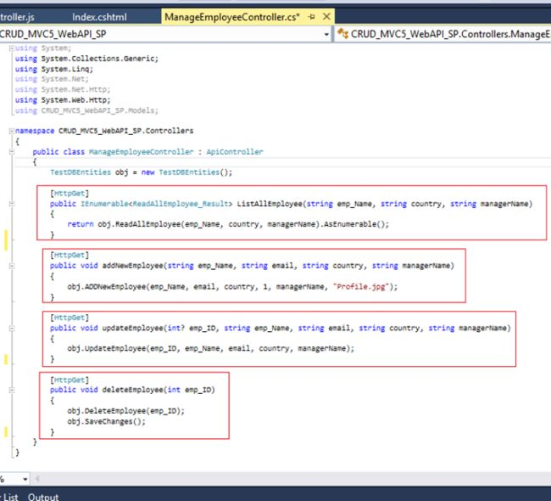  
Image 19.  
  
Now to add the AngularJs reference to your project. So right-click on your project in the Solution Explorer as in the following, then click*Manage NuGet Packages...*  
  
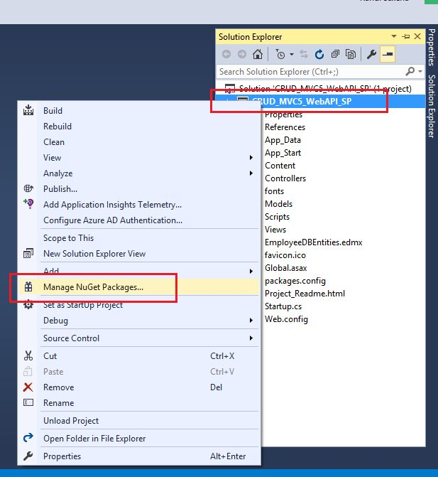  
Image 20.  
  
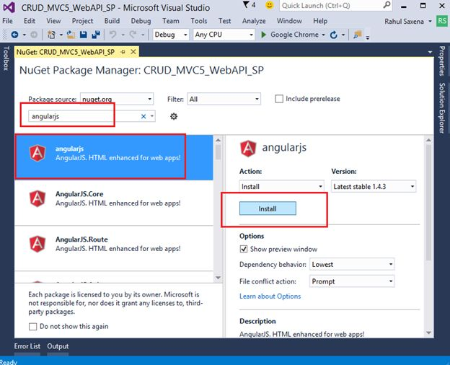  
Image 21.  
  
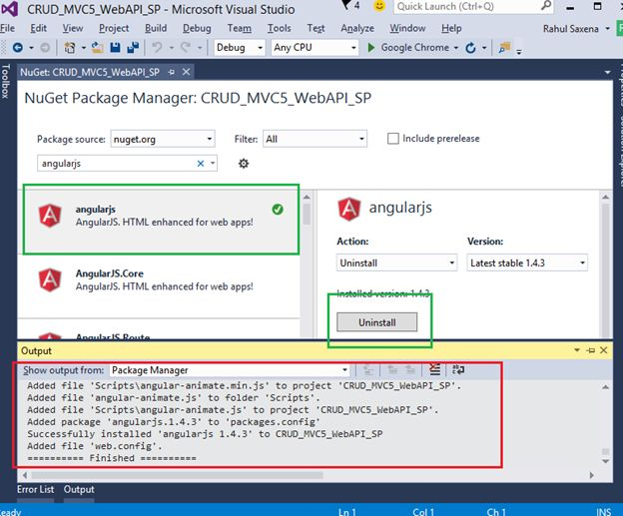  
Image 22.  
  
Now create a new folder under the Scripts Folder, then right-click MyScripts and select AngularController as in the following:  
  
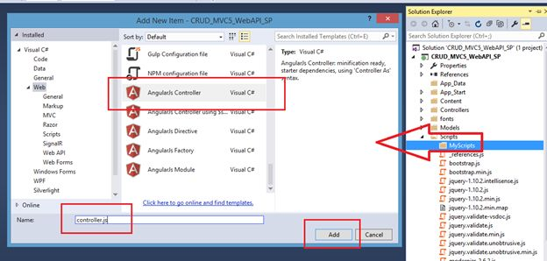  
Image 23.  
  
Here's the code:

1. // <reference path="../angular.js" />
2. /// <reference path="../angular.min.js" />
3. /// <reference path="../angular-animate.js" />
4. /// <reference path="../angular-animate.min.js" />
6. var app;
7. (function () {
8. app = angular.module("RESTClientModule", ['ngAnimate']);
9. })();
11. app.controller("AngularJs_ManageEmployeeInfoController", function ($scope, $timeout, $rootScope, $window, $http) {
12. $scope.date = **new** Date();
13. $scope.empNameSearch = "";
14. $scope.empCountrySearch = "";
15. $scope.ManagerNameSearch = "";
17. $scope.ManageEMP_Info = **false**;
18. $scope.ListEmployee = **true**;
19. $scope.searchEmployee = **true**;

22. $scope.EmpIds = 0;
23. $scope.empName = "";
24. $scope.empEmail = "";
25. $scope.empCountry = "";
26. $scope.empManager = "";
28. getEmployeeList($scope.empNameSearch, $scope.empCountrySearch, $scope.ManagerNameSearch);
30. function getEmployeeList(EmployeeName, Country, ManagerName) {
31. $http.**get**('/api/ManageEmployee/', { **params**: { emp_Name: EmployeeName, country: Country, managerName: ManagerName } }).success(function (data) {
32. $scope.Employees = data;
33. $scope.ManageEMP_Info = **false**;
34. $scope.ListEmployee = **true**;
35. $scope.searchEmployee = **true**;
36. **if** ($scope.Employees.length > 0) {
37. }
38. })
39. .error(function () {
40. $scope.error = "Some Error.";
41. });
42. }
44. //Search
45. $scope.searchEmp = function () {
47. getEmployeeList($scope.empNameSearch, $scope.empCountrySearch, $scope.ManagerNameSearch);
48. }
50. //Edit Employee Details
51. $scope.editEmployeeInfo = function editEmployeeInfo(Employee_ID, Name, Email, Country, ManagerName) {
52. cleardetails();
53. $scope.EmpIds = Employee_ID;
54. $scope.empName = Name
55. $scope.empEmail = Email;
56. $scope.empCountry = Country;
57. $scope.empManager = ManagerName;
59. $scope.ManageEMP_Info = **true**;
60. $scope.ListEmployee = **true**;
61. $scope.searchEmployee = **true**;
62. }
64. //Delete Dtudent Detail
65. $scope.Employee_Delete = function Employee_Delete(EmpIds, Name) {
66. cleardetails();
67. $scope.EmpIds = EmpIds;
68. var delConfirm = confirm("Are you sure you want to delete the Employee " + Name + " ?");
69. **if** (delConfirm == **true**) {
71. $http.**get**('/api/ManageEmployee/deleteEmployee/', { **params**: { emp_ID: $scope.EmpIds } }).success(function (data) {
72. alert("Employee Deleted Successfully!!");
73. cleardetails();
74. $scope.empNameSearch = "";
75. $scope.empCountrySearch = "";
76. $scope.ManagerNameSearch = "";
77. getEmployeeList($scope.empNameSearch, $scope.empCountrySearch, $scope.ManagerNameSearch);
78. })
79. .error(function () {
80. $scope.error = "Some Error.";
81. });
83. }
84. }
86. $scope.AddEmployeeForm = function () {
87. cleardetails();
88. $scope.ManageEMP_Info = **true**;
89. $scope.ListEmployee = **true**;
90. $scope.searchEmployee = **true**;
91. }
93. function cleardetails() {
94. $scope.EmpIds = 0;
95. $scope.empName = "";
96. $scope.empEmail = "";
97. $scope.empCountry = "";
98. $scope.empManager = "";
99. }
101. //Form Validation
102. $scope.Message = "";
103. $scope.IsFormSubmitted = **false**;
104. $scope.IsFormValid = **false**;
105. $scope.$watch("f1.$valid", function (isValid) {
106. $scope.IsFormValid = isValid;
107. });
109. //Save-Edit Employee
110. $scope.saveDetails = function () {
112. $scope.IsFormSubmitted = **true**;
113. **if** ($scope.IsFormValid) {
114. **if** ($scope.EmpIds == 0) {
115. $http.**get**('/api/ManageEmployee/addNewEmployee/', { **params**: { emp_Name: $scope.empName, email: $scope.empEmail, country: $scope.empCountry, managerName: $scope.empManager } }).success(function (data) {
116. alert("Employee Added Successfully.");
117. cleardetails();
118. $scope.empNameSearch = "";
119. $scope.empCountrySearch = "";
120. $scope.ManagerNameSearch = "";
121. getEmployeeList($scope.empNameSearch, $scope.empCountrySearch, $scope.ManagerNameSearch);
123. })
124. .error(function () {
125. $scope.error = "Some Error.";
126. });
127. }
128. **else** {
129. $http.**get**('/api/ManageEmployee/updateEmployee/', { **params**: { emp_ID: $scope.EmpIds, emp_Name: $scope.empName, email: $scope.empEmail, country: $scope.empCountry, managerName: $scope.empManager } }).success(function (data) {
131. alert("Employee Updated Successfully");
132. cleardetails();
133. $scope.empNameSearch = "";
134. $scope.empCountrySearch = "";
135. $scope.ManagerNameSearch = "";
136. getEmployeeList($scope.empNameSearch, $scope.empCountrySearch, $scope.ManagerNameSearch);
138. })
139. .error(function () {
140. $scope.error = "Some Error.";
141. });
142. }
144. }
145. **else** {
146. $scope.Message = "All the fields are required.";
147. }
148. }
149. });

Now for adding a new controller right-click on the Controller, select Add and click Controller as in the following:  
  
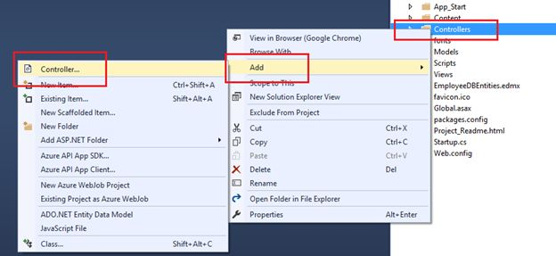  
Image 24.  
  
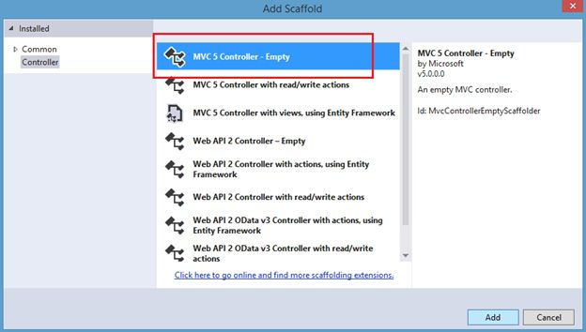  
Image 25.  
  
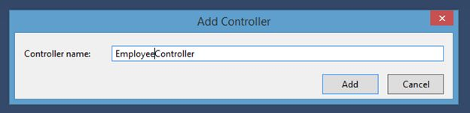  
Image 26.  
  
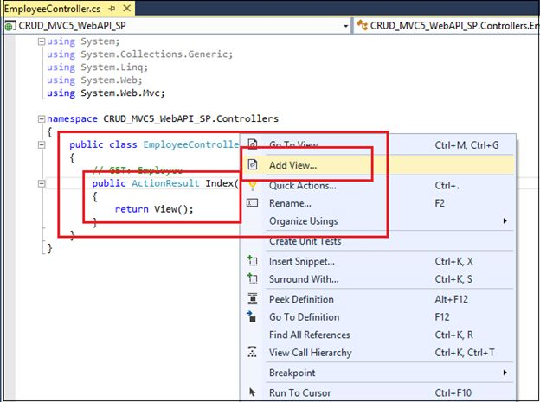  
Image 27.  
  
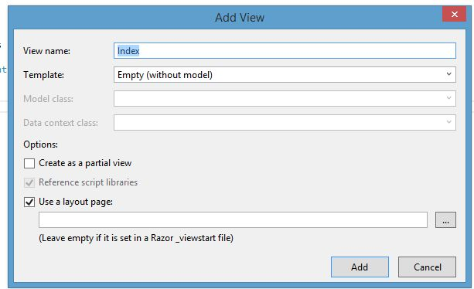  
Image 28.  
  
Here's the code in Index.cshtml:

1. <html data-ng-app="RESTClientModule">
2. @{
3. ViewBag.Title = "Manage Employee Information Uisng MVC 5 , WebAPI2, AngularJS with Stored Procedure";
4. }
5. <body data-ng-controller="AngularJs_ManageEmployeeInfoController">
6. <table style='width: 99%; background-color:skyblue; text-align:center;'>
7. <tr ng-show="searchEmployee">
8. <td>
9. <table style=" background-color:crimson; border: solid 4px green; padding: 5px;width: 99%; color:white;" cellpadding="2" cellspacing="2">
10. <tr>
11. <td>
12. <b>Name</b>
13. : <input type="text" name="txtEmpName" ng-model="empNameSearch" value="" />
14. </td>
15. <td>
16. <b>   Country </b> :
17. <input type="text" name="txtCountry" ng-model="empCountrySearch" />
18. </td>
19. <td>
20. <b>   Manager Name </b> :
21. <input type="text" name="txtManager" ng-model="ManagerNameSearch" />
22. </td>
23. <td>
24. <input type="submit" value="Search Employee" ng-click="searchEmp()" />
25. </td>
26. <td align="right">
27. <input type="button" value="Add New Employee" ng-click="AddEmployeeForm()" />
28. </td>
29. </tr>
30. </table>
31. </td>
32. </tr>
33. <tr ng-show="ManageEMP_Info">
34. <td>
35. <table style="border:solid 4px blue; background-color:orange; width:100%;">
36. <tr>
37. <td width="20"></td>
38. <td valign="top">
39. <form novalidate name="f1" ng-submit="saveDetails()">
40. <table style="color:#0d3d2b; font-weight:bold; font-size:12pt; text-align:right;">
41. <tr>
42. <td>
43. Employee ID :
44. </td>
45. <td>
46. <input type="text" name="txtEmpId" ng-model="EmpIds" value="0" style="background-color:tan" **readonly** />
47. </td>
48. <td>
49. Name :
50. </td>
51. <td>
52. <input type="text" name="txtEmpName" ng-model="empName" placeholder=" Employee Name..." required />
53. <br />
54. <span **class**="error" ng-show="(f1.file.$dirty || IsFormSubmitted) && f1.txtEmpName.$error.required">Name required!</span>
55. </td>
56. </tr>
57. <tr>
58. <td>
59. Email :
60. </td>
61. <td>
62. <input type="text" name="txtEmail" ng-model="empEmail" placeholder=" Email..." required />
63. <br />
64. <span **class**="error" ng-show="(f1.file.$dirty || IsFormSubmitted) && f1.txtEmail.$error.required">Email required!</span>
65. </td>
66. <td>
67. Country :
68. </td>
69. <td>
70. <input type="text" name="txtCountry" ng-model="empCountry" placeholder=" Country ..." required />
71. <br />
72. <span **class**="error" ng-show="(f1.file.$dirty || IsFormSubmitted) && f1.txtCountry.$error.required">Country required!</span>
73. </td>
74. </tr>
75. <tr>
76. <td>
77. Manager Name:
78. </td>
79. <td>
80. <input type="text" name="txtManager" ng-model="empManager" placeholder=" Manager ..." required />
81. <br />
82. <span **class**="error" ng-show="(f1.file.$dirty || IsFormSubmitted) && f1.txtManager.$error.required">Manager Name required!</span>
83. </td>
84. <td colspan="2">
85. <input type="submit" value="Save Employee" style="background-color:#336699;color:#FFFFFF" required />
86. </td>
87. </tr>
88. </table>
89. </form>
90. </td>
91. </tr>
92. </table>
93. </td>
94. </tr>
95. <tr ng-show="ListEmployee">
96. <td>
97. <table style="width:100%;">
98. <tr style="background-color:darkgreen; color:white; font-weight:bold;">
99. <td width="120px" align="center">Name</td>
100. <td width="120" align="center">Email</td>
101. <td width="80" align="center">Country</td>
102. <td width="200" align="center">Manager Name</td>
103. <td width="40" align="center">Edit</td>
104. <td width="40" align="center">Delete</td>
105. </tr>
106. <tbody data-ng-repeat="emp in Employees">
107. <tr style="background-color:whitesmoke; font-family:Cambria, Cochin, Georgia, Times, Times New Roman, serif; font-size:11pt; color:midnightblue; text-align:left; padding-left:10px;">
108. <td style="width:120px;">
109. {{emp.Name}}
110. </td>
112. <td>
113. {{emp.Email}}
114. </td>
116. <td>
117. {{emp.Country}}
118. </td>
120. <td>
121. {{emp.ManagerName}}
122. </td>
123. <td align="center">
124. <span style="color:#9F000F;">
125. <input type="submit" value="Edit" ng-click="editEmployeeInfo(emp.ID,emp.Name,emp.Email,emp.Country,emp.ManagerName)" />
126. </span>
127. </td>
129. <td align="center">
130. <span style="color:#9F000F;">
131. <input type="submit" value="Delete" ng-click="Employee_Delete(emp.ID,emp.Name)" />
132. </span>
133. </td>
135. </tr>
136. </tbody>
137. </table>
139. </td>
140. </tr>
141. </table>
142. </body>
143. </html>
145. <script src="~/Scripts/angular-animate.js"></script>
146. <script src="~/Scripts/angular.js"></script>
147. <script src="~/Scripts/angular.min.js"></script>
148. <script src="~/Scripts/angular-animate.min.js"></script>
149. <script src="~/Scripts/MyScripts/controller.js"></script>

To make your view as the default run you need to make a change in the rout.config like the following:  
  
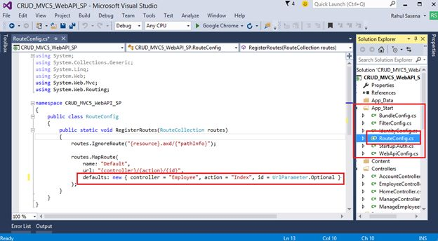  
Image 29.  
  
Now run your application: